Basic G1000 Mission Observer Quick Reference Guide

KEY:
B Turn big (outer) knob
S Turn small (inner) knob
RANGE Press named knob or softkey
ENT Press named hardkey

All Tasks start at Map Page 1 (hold CLR for 2 seconds)

Mark and Save a Point
- Press RANGE once.
- Within 5 seconds press ENT
- B to “Create User Waypoint”
- ENT
- S left to ‘1’ (for first, ‘2’ for second…)
- ENT
- Hold CLR for 2 seconds → Map Page 1

Retrieve & Delete Waypoint (post-flight)
- B to WPT page group.
- S to “User Waypoint” page.
- Press S knob to get cursor.
- B down to “User Waypoint List”, continue to “1”.
- Write down “Information” (Lat/Long info)
- DELETE softkey
- ENT to verify delete
- <repeat for all numbered waypoints>

Show Quarter Grid Lat/Longs
- Hold CLR for 2 seconds → Map Page 1
- Turn RANGE knob until Map Scale shows “30nm”.
- If lat/long lines are already showing, skip next Task “Enable Map Lat/Longs”.

Enable Map Lat/Longs
- MENU
- B to Map Setup
- ENT
- S to “Land”
- ENT
- B to “LAT/LON”
- Using B to move field to field, S to modify a field, and ENT to save: Set ‘TEXT’ = Small, ‘RNG’ = 30nm

Mission Master – power on CAP-specific equipment (FM, DF)
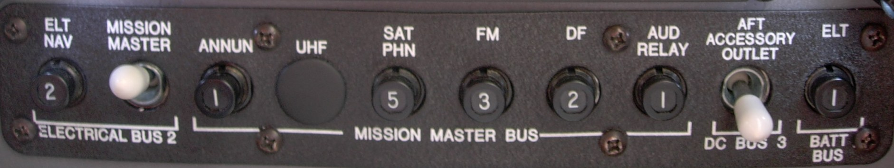

FM Radio Setup
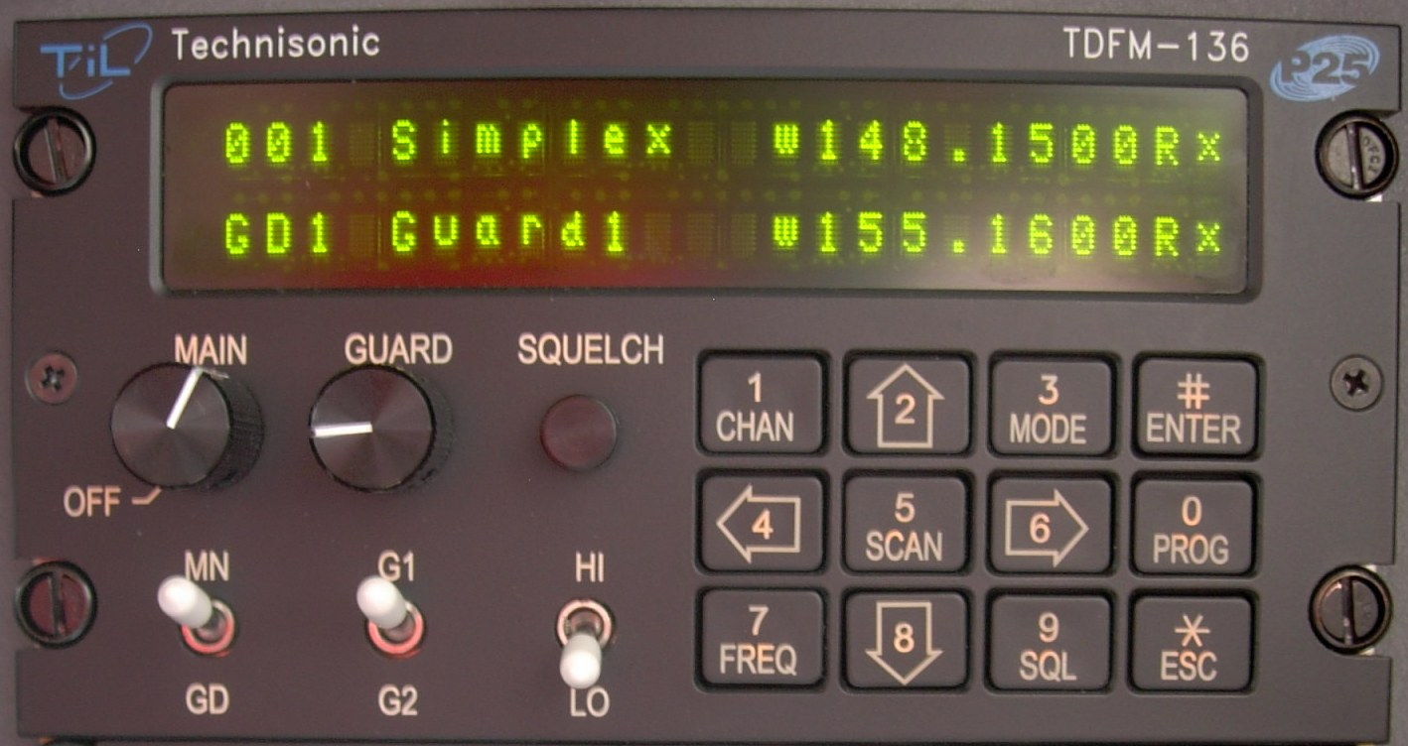
Main = Volume – set about halfway as shown
Guard – turn all the way down (counter-clockwise)
Squelch – press to verify you can hear the radio (COM3)
White switches – up up down as shown
Keypad: up / down arrows (2, 8) to set brightness
left / right arrows (4, 6) to go up / down channels
Basic G1000 Mission Observer Quick Reference Guide

Select Switches Setup
Good – both Green | Bad – either one blue
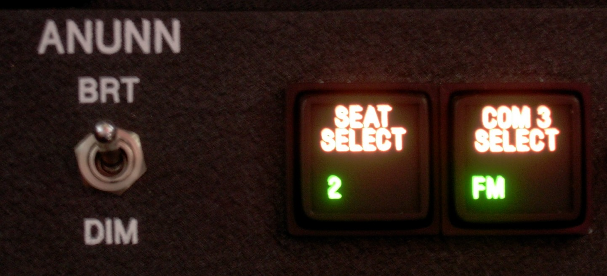 | 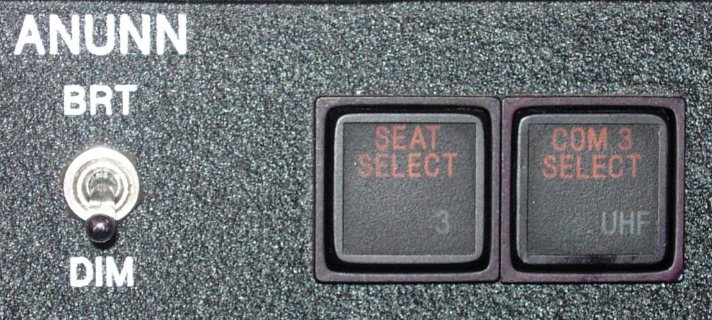

Comm Audio Panel Setup
 | - Mic – select for transmitting  - Right side COM1, COM2, COM3 – all should be selected for listening  - Also select AUX to listen to Becker DF

Becker Direction-Finding Setup
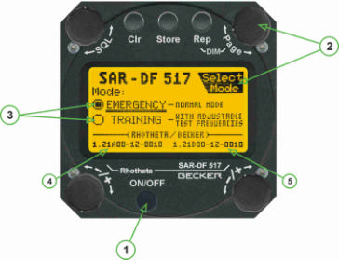
- (1) Power on/off (or use Mission Master)
- During power-up, use Page Knob (2) to set Emergency or Training mode. You only have three seconds.
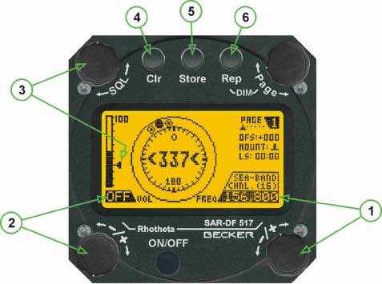
- Use bottom right knob (1) to select Frequency
- Use Volume (2) to set Volume
- Use SQL (3) to set Squelch level (triangle in the black)
- Listen by selecting AUX on Comm audio panel
- If no signal is heard, try listening on COM2
Advanced G1000 MO Quick Reference Guide

Grid Search – Mission “Fast Launch” – set one corner
KEY:
B Turn big (outer) knob
S Turn small (inner) knob
RANGE Press named knob or softkey
ENT Press named hardkey

All Tasks start at Map Page 1 (hold CLR for 2 seconds)

See next page for how-to modify all 4 grid points & create flight plan

Do this after Engine Start, before takeoff. Eyes outside while plane is taxiing – do this only while plane is stationary

Clear all Flight Plans
- FPL
- S to “Flight Plan Catalog” page.
- MENU
- S to “Delete All”
- ENT
- ENT

Modify 1 existing Waypoint: GPTNW
- Go to Map Page 1 (hold CLR for 2 seconds)
- B to WPT page group.
- S to “User Waypoint” page.
- Press S knob to get cursor.
- B down to “User Waypoint List”, continue to GPTNW.
- ENT to get to detailed info & modify the waypoint
- B to “Information” area.(lat/long values)
- S right once to start editing.
- Using B to move field to field, and S to modify a field, edit the lat/long.
- When correct: ENT to save.

Advanced G1000 MO Quick Reference Guide

Grid Search – Sarex “Slow Launch”
Modify all 4 Waypoints, create flight plan “grid box”
Do this after Engine Start, before or after takeoff. Eyes outside while plane is taxiing – do this only while the airplane is stationary

KEY:
B Turn big (outer) knob
S Turn small (inner) knob
RANGE Press named knob or softkey
ENT Press named hardkey

All Tasks start at Map Page 1 (hold CLR for 2 seconds)

Clear all existing Flight Plans
- FPL
- S to “Flight Plan Catalog” page.
- MENU
- S to “Delete All”
- ENT
- ENT

Modify 4 existing Waypoints (eg GPTNE)
- B to WPT page group.
- S to “User Waypoint” page.
- Press S knob to get cursor.
- B down to “User Waypoint List”, continue to “GPTNE”.
    - ENT to get to detailed info & modify.
    - B to lat/long area.
    - S right one to start editing.
    - Using B to move field to field, and S to modify a field, edit the lat/long.
    - When correct: ENT to save.
    - B right to next waypoint, eg GPTNW.
    - <Repeat for all 4>
- Hold CLR for 2 seconds → Map Page 1
- RANGE out, PAN*, verify 4 GPT waypoints form a square.

Create a new Flight Plan
  - FPL
  - Press S knob to get cursor.
    - B to put cursor on blank line.
    - S right once to add a waypoint.
    - S left once to get to shortcuts
    - S right to “RECENT”
    - B right (down) to desired waypoint name
    - ENT
    - ENT
    - <Repeat for all waypoints>

Store a Flight Plan
- FPL
- S to “Active Flight Plan” page.
- MENU
- B to “Store Flight Plan”.
- ENT (dialog asks to store to #1?)
- ENT (yes, store it)

*PAN*
Press RANGE to get arrow pointer. Move “joy stick” to move pointer on map

