Technisonic TDFM-136 Radio

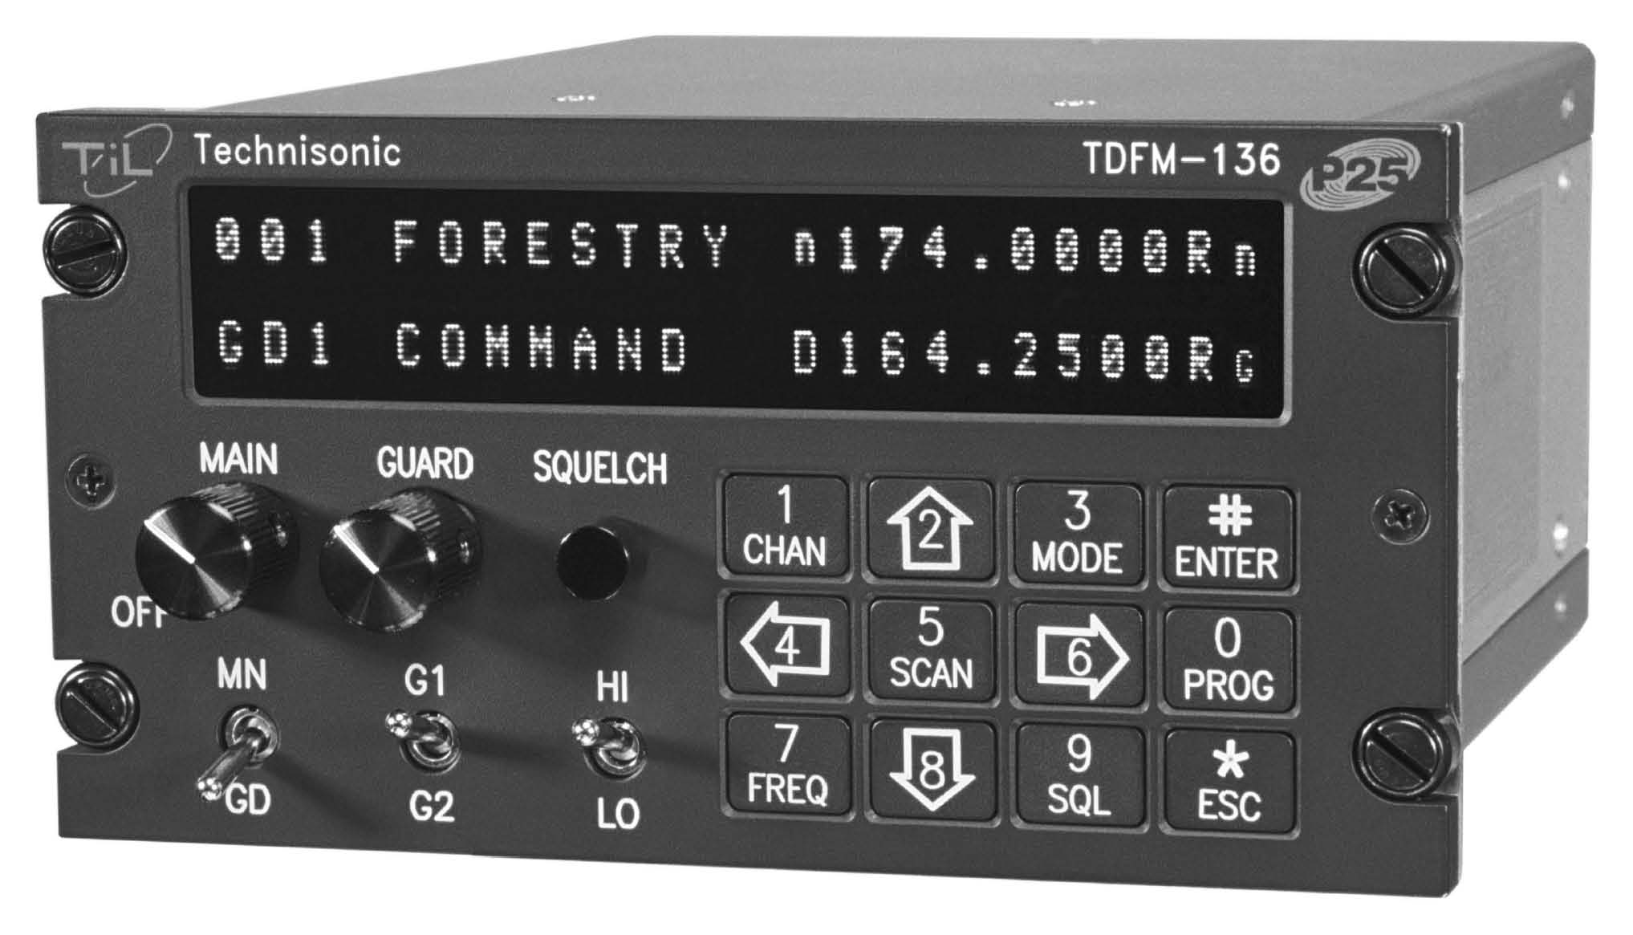
Power Up
- To power up the Technisonic TDFM radio make sure the Mission Master toggle switch is in the on position. This switch is located just to the right of the co-pilots side control yoke.
- Desired Settings:
  - Main switch is turned on and set to a mid-volume level.
  - Guard volume switch is turned down.
  - MN/GD switch is set to MN.
  - HI/LO switch is in the LO position (use HI power only if needed, HI can distort or “motor-boat”)
- If you get in trouble with a command, press the */ESC key to escape the command.
- Use COM3 to listen and transmit on FM.
- Press TDFM Squelch to verify you are listening to COM3 and to set the “Main” Volume level.

Display Brightness
- To adjust the display brightness, use the 2 and 8 keys to increase/decrease the display brightness
Channel Selection
- The FM radio is pre-programmed with appropriate CAP frequencies. See the communications section of the aircraft book for the channel plan.
- To scroll through channels use the 4 and 6 keys to scroll backwards and forwards through the channels.
- To select a channel by channel number, press the 1/CHAN key and enter a 3 digit channel (001 to 200) using the numeric key pad. To accept the entry, press the #/ENTER key. To abandon the selection, press the */ESC key. Note the MN/GD switch MUST be in the MN position.
- Do not use the 7/FREQ key unless you know what you are doing. If in doubt, use the */ESC key to get out of any command.
- If the keypad appears not to be responding, it may be locked. To unlock the keypad, hold the */ESC key for two seconds. This should unlock the keypad.

Talking on the radio
- The TDFM radio is COM3 on the audio panel.
- To monitor the FM radio, press “COM3” to illuminate it. Remember to do this on both audio panels for everyone to be listening to COM3
- To transmit on the FM radio, press “COM3 MIC”. Note the selected MIC sets that COM to receive mode.
- The PTT switch will now transmit on the FM radio when pressed.

