Becker SAR DF-517

- The Becker SAR DF-517 is an automatic direction finder. It supports 121.5, 243 and 406 MHz frequencies.
- The DF unit will display a bearing relative to the nose of the aircraft for signals received.
- There are two sets of frequencies that may be selected. These are Emergency Mode or Training Mode frequencies.
- The Emergency Mode or Training Mode can only be selected at power up.

Power Up

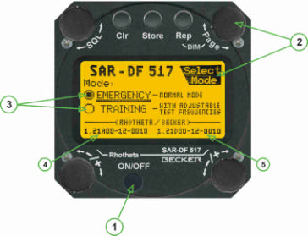
- The Mission Master switch must be on for the DF unit to operate.
- On power up (1), the user must verify Emergency or Training mode. To change the setting, turn the page dial (2) and select the appropriate mode (3). Note that power up is the only way to switch between Emergency and Training Mode. This will be displayed for a few seconds at power up and will retain this mode on power down.

Initial Setup

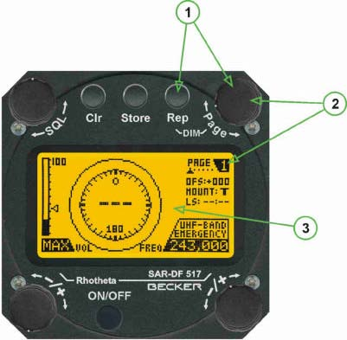

- The Page dial (2) is used to switch the DF-517 between the different pages.
- Internal brightness is normally adjusted by holding the Rep button and rotating the page dial (1). However, in N652CP brightness is controlled by the pilot’s far left “Dimming” -> Avionics knob.
- The COMM radios are more sensitive than the Becker for receiving a far-away signal. Recommend using COM2 (un-squelched) to listen for a signal until the Becker can pick up the signal.
DF-517 DFing

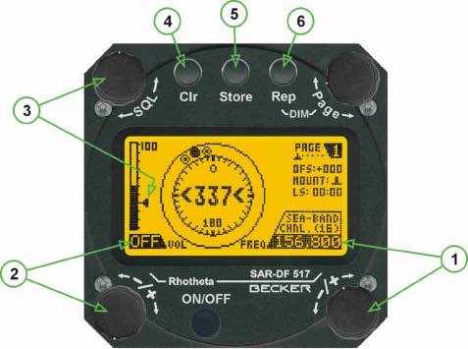

- Select the desired frequency to DF by using the bottom right rotary dial (1) to select the desired preprogrammed frequency.
- Use the volume (2) rotary dial to set the volume level.
- Once the desired frequency is selected, use the SQL (3) dial to select the squelch level.
- The DF signal can be heard by selecting AUX on the audio panel.
- DFing is done using Page 1 or Page 2.
- Page 1 displays a full circle with the signal and bearing in 360o.
- Page 2 displays a 45° window with the relative bearing and signal.

DF-517 Page 1 Display
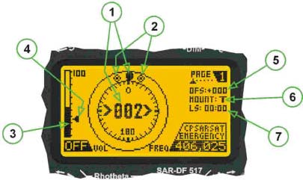

- (1) The signal and relative bearing
- (2) Spread – maximum deviation of un-averaged bearing
- (3) Signal Strength
- (4) Squelch level
- Tracking frequency 406.025 in Emergency mode.
- Note that to DF a signal, the squelch level must be below the maximum signal strength.

DF-517 Page 2 Display
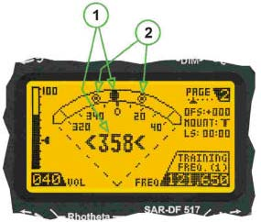 | (1) Signal level and relative bearing  (2) Position error  Tracking Freq. 121.650 in Training Mode
DF-517 Page 3 Display
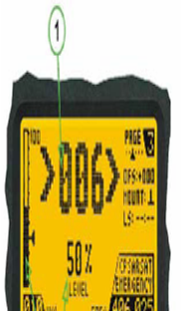  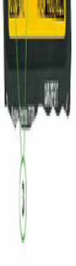 | - Signal level and relative bearing  (3) Receive level - Field Strength, both graphically and textually

DF-517 frequencies

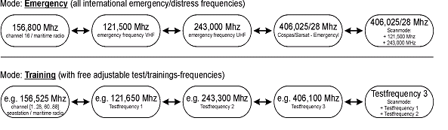

DF-517 Programming Frequencies
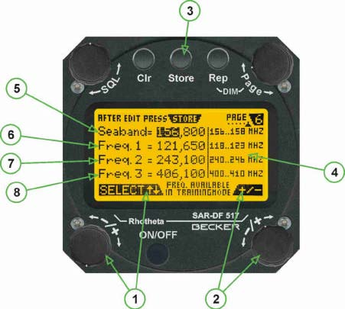

- Page 6 enables you to adjust the training frequencies.
- (1) >±Select< rotary switch selecting the trainings-frequency (MHz/kHz).
- (2) >±< rotary switch changing the frequency. Confirm the changed value by pressing pushbutton >STORE< .
- (3) >STORE< Pushbutton to confirm changed values.

